Electron shells overlap
- From previous knowledge, we know that:
- The larger the value of n, the higher the energy level and the further from the nucleus.
- That the electron shells get closer together as you move away from the nucleus.
- As we move from n = 1 to n = 4, a new type of sub shell is added.
- Within a shell the energies of the sub - shells increases in the order s, p, d and f.
- After 3p it gets a bit complicated:
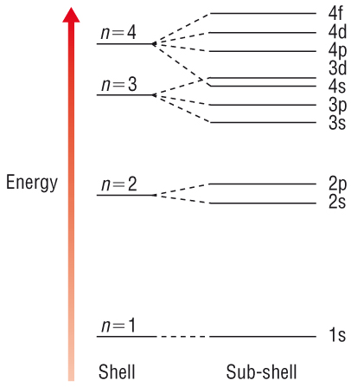 | - The 4s energy level is below the 3d energy level.  - This means that the 4s orbital fills before the 3d orbitals. (according to the Aufbau Principle)
- Remember the orbitals fill up in energy level order from the bottom up:-

