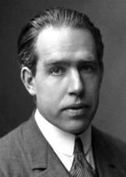
Niels Henrik David Bohr was born in Copenhagen on October 7, 1885, as the son of Christian Bohr, Professor of Physiology at Copenhagen University, and his wife Ellen, née Adler. Niels, together with his younger brother Harald (the future Professor in Mathematics), grew up in an atmosphere most favourable to the development of his genius - his father was an eminent physiologist and was largely responsible for awakening his interest in physics while still at school, his mother came from a family distinguished in the field of education.
The Nobel Prize in Physics 1922 was awarded to Niels Bohr "for his services in the investigation of the structure of atoms and of the radiation emanating from them".

