Fritz Wolfgang London
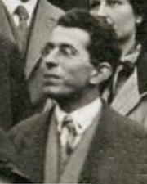
Fritz London (1928)
Born | March 7, 1900  Breslau, Silesia, Germany
Died | March 30, 1954 (aged 54)  Durham, North Carolina
Residence | USA
Citizenship | German, later USA
Fields | Theoretical Physics
Institutions | University of Berlin  University of Oxford  Collège de France  Duke University
Known for | Work on quantum theory  London moment  London dispersion forces;
Notable awards | Lorentz Medal, 1953

